**Introduction**

In recent years, online learning platforms have become increasingly popular as they offer flexible, accessible opportunities for individuals to advance their skills, participate in internships, and pursue sponsorship programs. This study focuses on a dataset from Excelerate, an organization that provides such online opportunities, specifically targeting training, internship, and sponsorship programs across a variety of demographics. The dataset captures sign-up and completion information, with insights segmented by gender, geographic location, and type of opportunity. By examining trends within these categories, this analysis aims to identify key patterns in participation and engagement. Understanding these patterns is crucial for informing the organization’s strategy to maximize inclusivity, boost engagement, and support participants from diverse backgrounds in completing their chosen programs.

**Project Objective**

The primary objective of this project is to conduct a detailed Exploratory Data Analysis (EDA) to uncover insights into the demographic composition, opportunity participation, and completion trends of the organization’s programs. Through this analysis, we aim to:

1. Evaluate gender and geographic distribution among participants to assess demographic inclusivity.
2. Identify trends in program engagement over time, with a focus on the types of opportunities attracting the highest participation.

Ultimately, the findings from this EDA will provide actionable recommendations to enhance the organization’s outreach, increase diversity in participation, and foster higher completion rates, aligning with its mission to deliver accessible, impactful learning opportunities to a global audience

Here is a detailed breakdown of each observed insight, along with interpretations and strategic recommendations:

1. **Gender Distribution Insights**

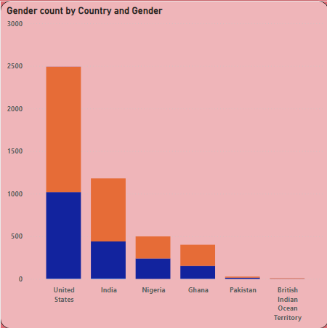

- ***Key Observation:***

* Males had the highest gender count at 2,736, followed by females at 1,860, and those who chose "Don't want to specify" at only 9.
* Males also showed the highest average gender count at 456, followed by females at 310, with a very low count of 3 for those who chose "Don't want to specify."
* Notably, in the United States, male participants represented 31.94% of the total gender count.

- ***Inference:***

* Male participants dominate the program, both in total counts and average gender count. This could indicate either a higher interest or access to these training opportunities among male individuals.
* The lower female and "Don't want to specify" counts may point to potential engagement or accessibility gaps.
* Since gender distribution also varies by location, the 31.94% representation of males from the United States might suggest higher awareness or interest among this group in the U.S. specifically, possibly influenced by socio-cultural or marketing factors.

- ***Suggestions:***

* Engagement Strategies: Consider conducting surveys to understand any barriers female and non-specified gender participants face. Addressing these through targeted outreach or program adjustments could help improve gender balance.
* Inclusive Marketing: Employ marketing strategies that appeal equally to all genders, and perhaps create campaigns that highlight successful female or gender-diverse participants.
* Regional Focus: Since males in the U.S. have a significant representation, exploring partnerships or further marketing in this region could strengthen the organization’s foothold.

1. **Program Enrollment by Education Level**

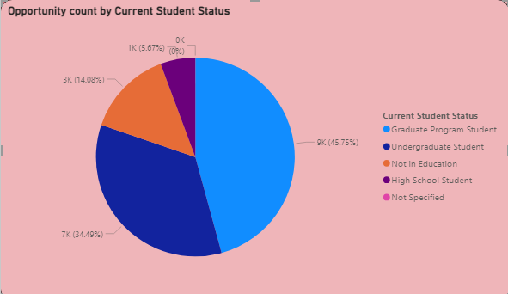

- ***Key Observation:***

* Graduate Program Students accounted for 45.75% of the opportunity count, making them the largest group in terms of participation.

- ***Inference:***

* Graduate students appear to be a primary audience for this training program, possibly due to the relevance of training content to their academic or career advancement.
* Other groups, potentially undergraduate or professional learners, seem less represented, which could indicate a narrower appeal or limited access for these groups.

- ***Suggestions:***

* Diversify Program Offerings: Consider introducing beginner-friendly modules or skill-based micro-courses to attract undergraduate or early-career professionals.
* Expand Outreach to Other Educational Levels: Explore partnerships with universities, community colleges, and workplaces to reach individuals at different educational stages or career levels.
* Career-Focused Content: Graduate students might be looking for direct career applications; adding career-oriented modules or certifications could enhance appeal to other demographics as well.

1. **Gender Count Variability**

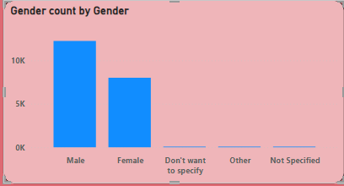

- ***Key Observation:***

* The range of gender counts spans significantly from 1 to 12,240, with "Male" participants reaching the highest at 12,240 and "Not Specified" having the lowest count of 1.

- ***Inference:***

* Such a stark difference suggests a potential lack of representation or interest among those who prefer not to specify their gender. The high count for males might indicate that marketing or content is resonating more strongly with male audiences.

- ***Suggestions:***

* Enhanced Inclusivity: Ensure the program is positioned as inclusive by using gender-neutral language and images in marketing and user interfaces, which may encourage participation from those who do not wish to disclose gender.
* Focused Outreach for Underrepresented Groups: Consider partnerships with organizations that promote diversity in education to increase engagement with underrepresented gender groups.

**Additional Considerations and Recommendations**

1. **Data Collection & Analysis:**

* Refine Gender Categories: Consider expanding the gender categories beyond "Male," "Female," and "Don't want to specify" to offer a more nuanced view of gender diversity.
* Regional Data Analysis: Perform deeper regional analysis to understand geographic patterns. Knowing which regions show higher or lower engagement can help in optimizing targeted outreach.

2. **Content Adaptation:**

* Customization: Allow users to customize training paths according to experience level and preferred learning pace. Personalized learning may improve overall completion rates and engagement.
* Feedback Mechanism: Introduce feedback loops within the courses to improve content based on real-time user input, especially from underrepresented demographics.

3. **User Retention & Conversion:**

* Track Completion Rates: Given the increase in opportunity count, evaluate completion rates to ensure growth is matched by successful program outcomes.
* Engagement Tools: Incorporate gamification, achievement badges, or networking opportunities to keep users motivated and engaged throughout their training.

4. **Long-Term Strategy:**

* Broaden Accessibility: Ensure that the content is accessible across different devices and locations, catering to users with varying levels of technological access and literacy.
* Career Services: For graduate-level participants, consider adding career counseling, job boards, or internships tied to completed courses to enhance the program's value.

By acting on these insights, the organization can potentially increase its reach, inclusivity, and program impact across diverse demographic groups and geographic regions, enhancing user satisfaction and success rates.